Computer Networks 1: Lab Work 03
Getting Familiar with Networking Devices

Student name:
Group: Student ID:

I. Lab Objectives
- Getting to know networking devices
- Understanding the functions of network devices
- Interconnecting network devices

II. Lab Content

1. Getting to know networking devices, your tutor will show you some of the devices as bellows:
- Network Interface Card (NIC)
- Switch
- Router
- Network Cables
- Access Point Router
- Modem(s)

2. Understanding the functions of network devices
a. Network Interface Card (NIC)

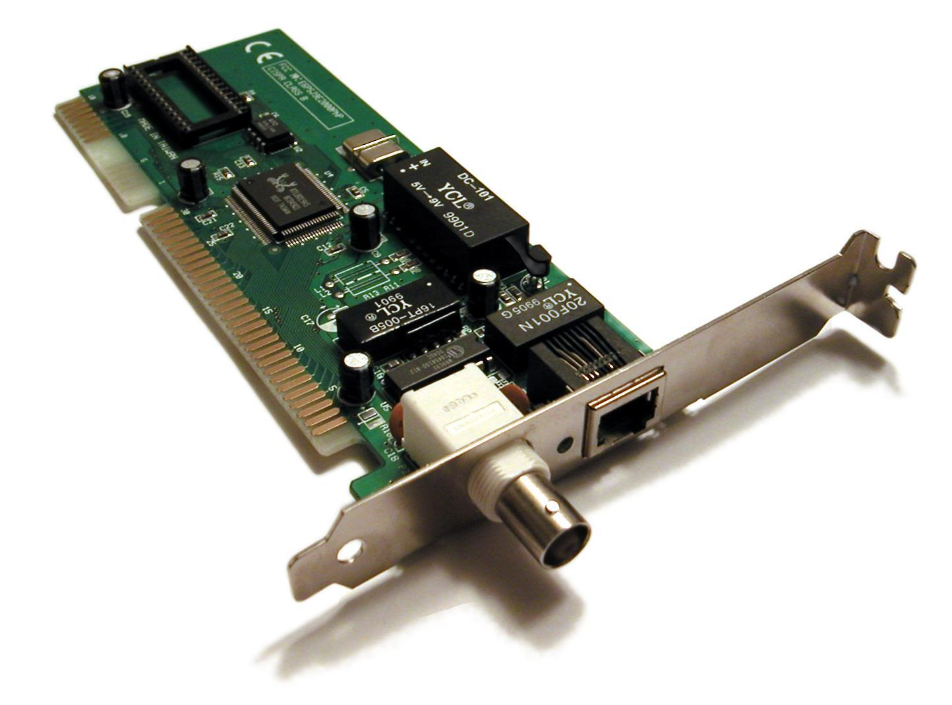
NIC function: ________________________________________________________
Check the NIC of your PC (or laptop), its MAC is ____________________________
Cables (and connectors) can be used to connect your NIC: _____________________

b. Switch
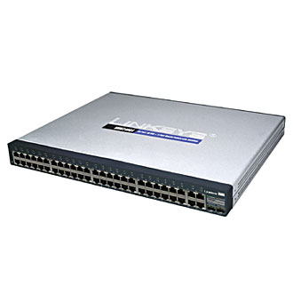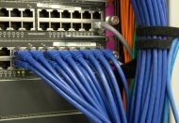
Role of switch in the network: ________________________________________________
Getting to know ports, type of cables and connectors to connect to switch

c. Router
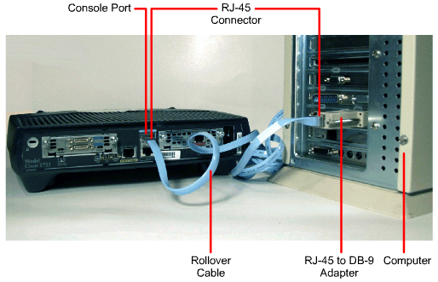

Role of router in the network: ________________________________________________
Getting to know ports, type of cables and connectors to connect to router

d. Access Point Router (AP)

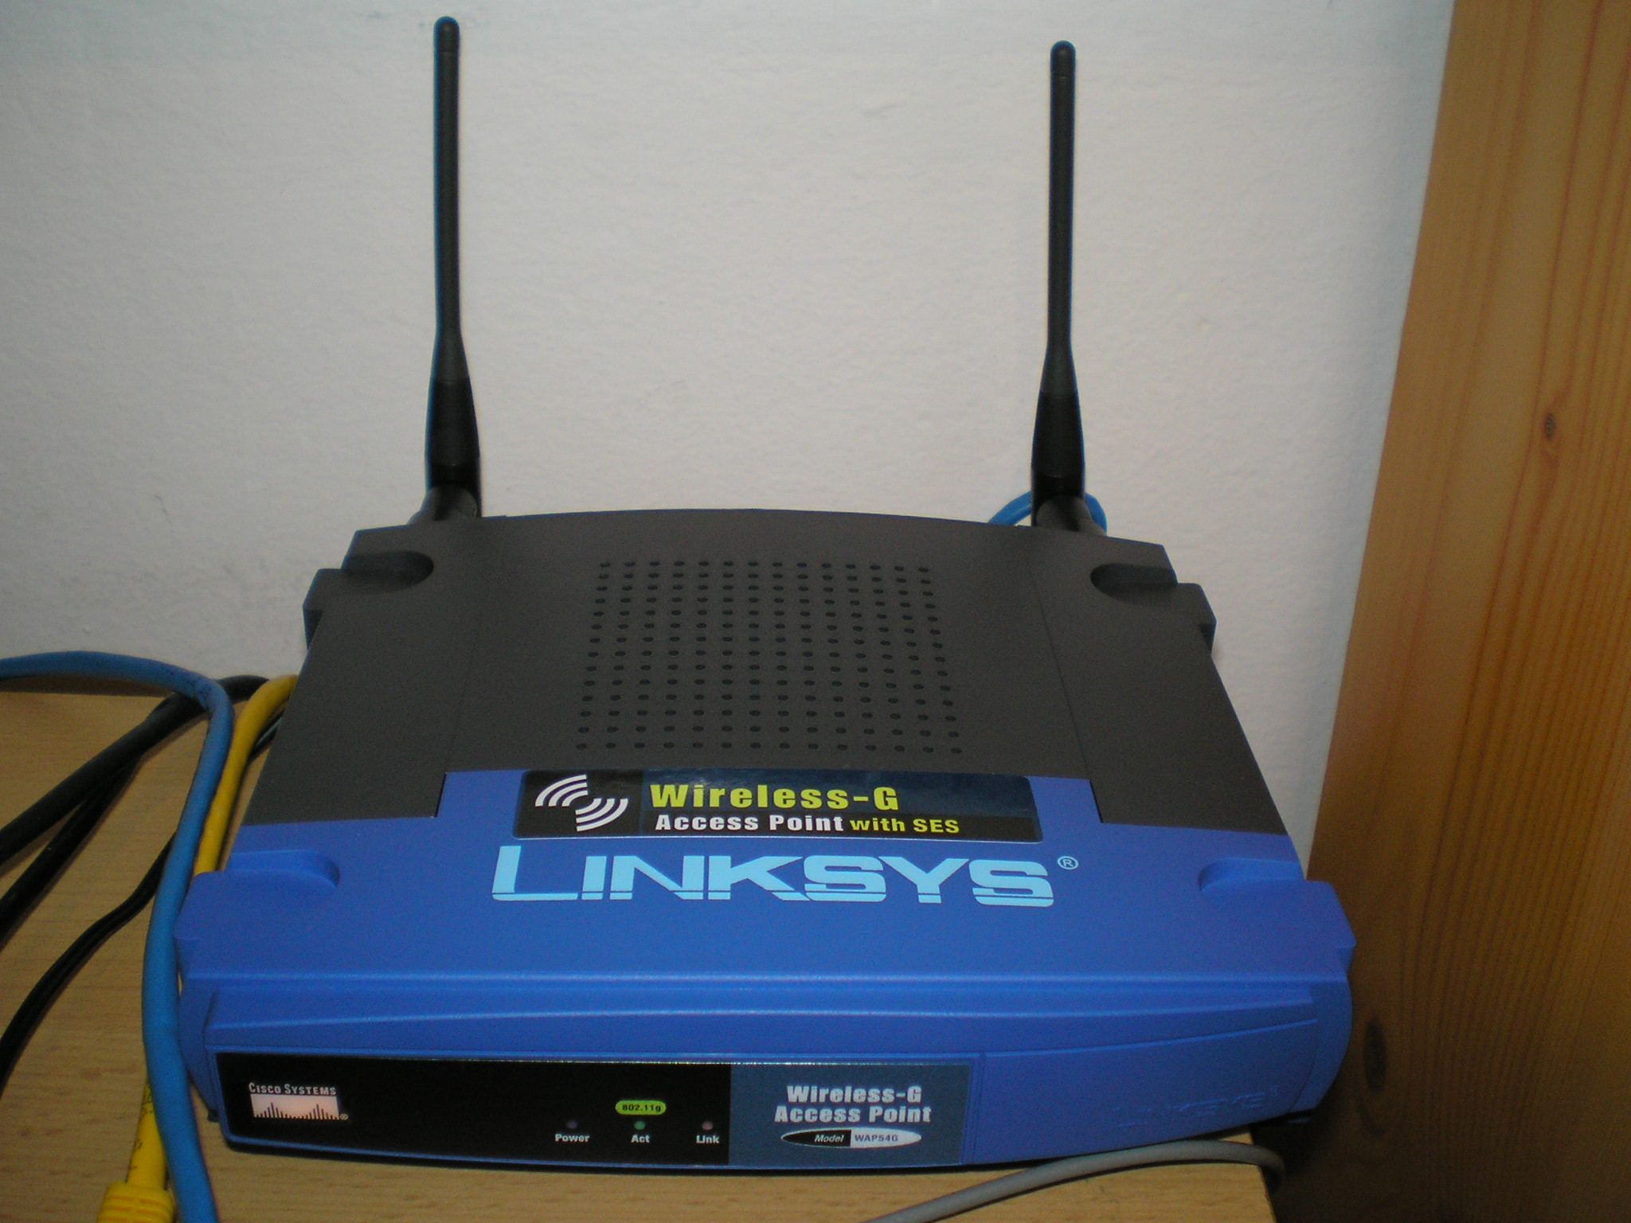
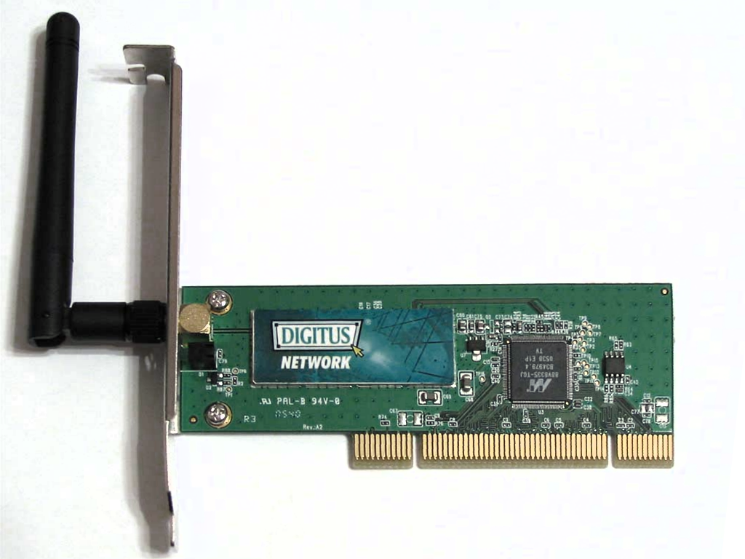

Role of AP router in the network: ______________________________________________
Getting to know ports, type of cables and connectors to connect to AP router

d. Modems

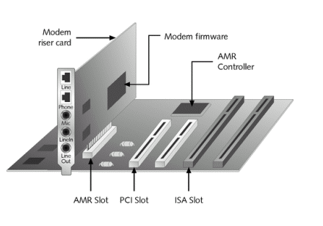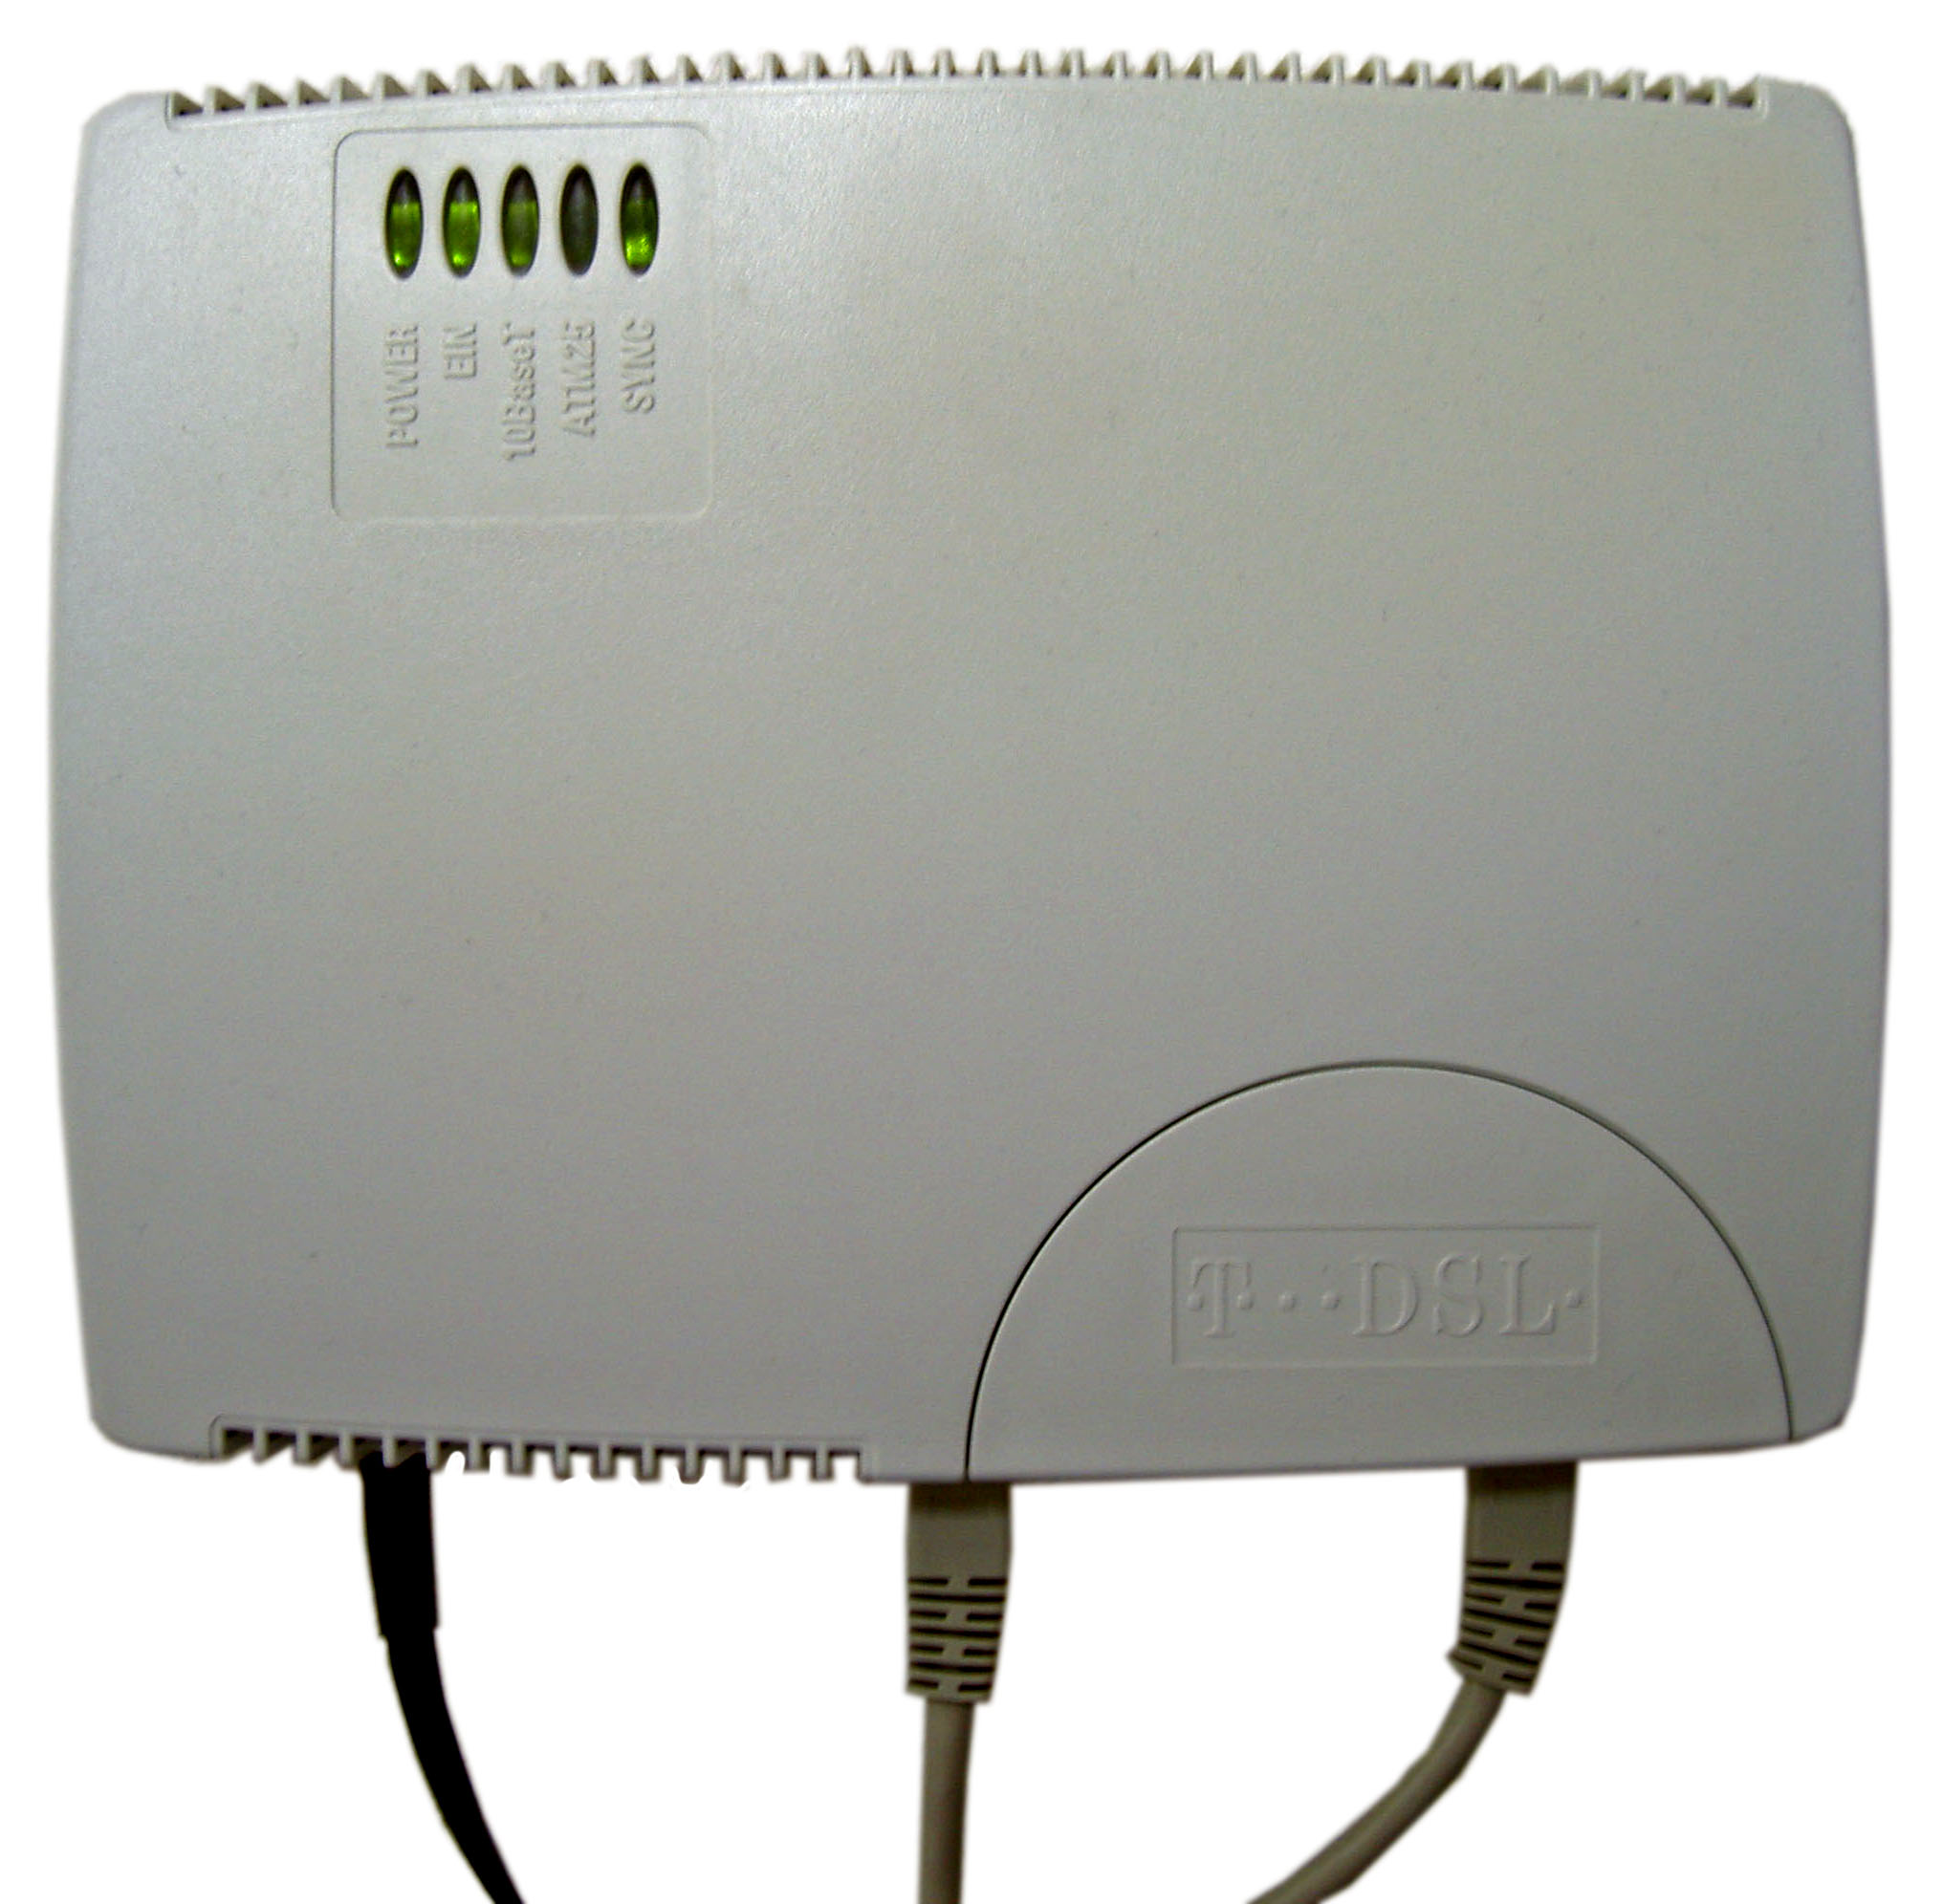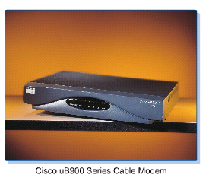

Distinguish:
- Dial-up Modem
- DSL Modem
- Cable Modem

For each type:
Role of the device in the network: ______________________________________________
Getting to know ports, type of cables and connectors to connect to the device

3. Interconnecting network devices

What type of cable is used for each connection?
a) ________________ cable is used to connect a host to a hub
b) ________________ cable is used to connect a host to a switch
c) ________________ cable is used to connect a host to a router

d) ________________ cable is used to connect a hub to a hub
e) ________________ cable is used to connect a hub to a switch
f) ________________ cable is used to connect a hub to a router

g) ________________ cable is used to connect a switch to a switch
h) ________________ cable is used to connect a switch to a router
k) ________________ cable is used to connect a router to a router

----------------------------------------------------------------------------------
Please, send comments and/or feedback to thai@cse.hcmut.edu.vn

